1. **Agenda**:
   1. We will study Kafka Producer CLI to produce data into Kafka Cluster Topic.
2. A screenshot of a computer

   Description automatically generated
3. Let’s see the output on the Conduktor UI.  
   
4. **--producer-property**: Used to enhance producer’s behavior like in case of batching or in the following scenario.  
   **Scenario**: --producer-property acks=all which means if we have replication-factor=3 which means a partition has 3 replicas each one of different broker in Kafka Cluster, then when sending a msg with acks=all, all those brokers should acknowledge the write.   
   
5. A screenshot of a computer

   Description automatically generated
6. 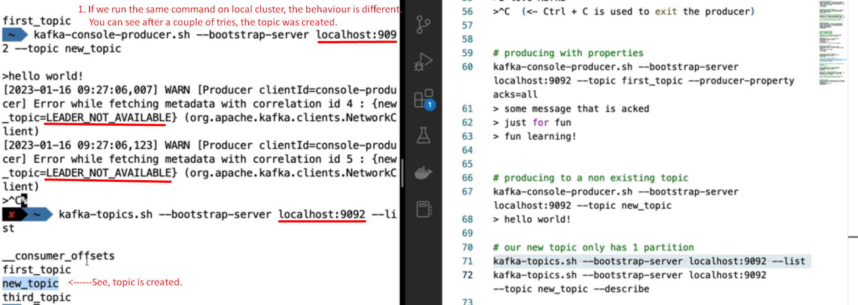  
     
   A screenshot of a computer screen

   Description automatically generated  
     
     
   A close up of a text

   Description automatically generated  
     
     
     
   Best practice is to disable the auto topic generation.
7. As we know till now we send msgs without any key which means msgs will be distributed across all the different partitions on different brokers.  
   But if we send msgs with same key, the msgs will land on the same partition so on the same broker.  
   See the following example of how to send msg with by configuring the producer property for key.A screenshot of a computer

   Description automatically generated  
     
   Let’s see the msgs on Conduktor visually.  
   A screenshot of a computer

   Description automatically generated  
     
   But we can not see the same key goes to the same partition right now, as we have only one partition so all the msgs go to the same partition.  
     
   With that key configuration, if we send msg with colon, we will face exception.  
   A screenshot of a computer

   Description automatically generated